|  |  |  |  |
| --- | --- | --- | --- |
| Name:  Class: | ____________________________________  ________________ | | Date:_________ |
|  | **Year 11 Essential Mathematics 2018**  / 12  Weighting: 1%  **Mini-Test 1.5**  **Topic – Units of Energy** | | |
| **Total Time:** | 15 minutes |  | |
| **Weighting:** | 1% |
| **Equipment:** | To be provided by the student: Pen, pencil, ruler,1 single sided A4 page of notes, scientific calculator | | |

**Full working out must be shown to get full marks. Attempt all questions.**

|  |
| --- |
| **Question 1** **4 marks** |

Convert the following to kilojoules.

1. i) 6070 joules ii) 250 calories iii) 867 joules iv) 5.8 Wh

|  |
| --- |
| **Question 2** **1 mark** |

An air conditioner has a power rating of 3.2 kW. Write this rating in watts.

|  |
| --- |
| **Question 3** **1****mark** |

During swimming training, Michael swam for 90 minutes burning off 3900 kJ of energy.

How many calories did he burn?



|  |
| --- |
| **Question 4****3****marks** |

Jayme has a recommended daily intake of 8700 kJ. She eats 60g of a fruit and nut trail mix with the following nutritional information.

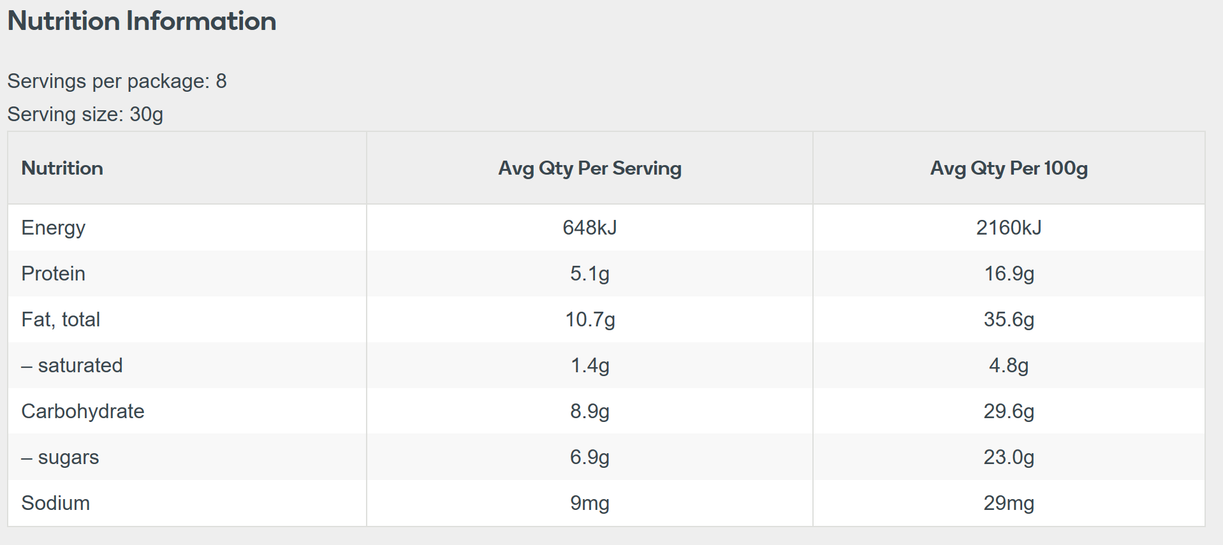

1. How many kilojoules of energy does Jayme consume?

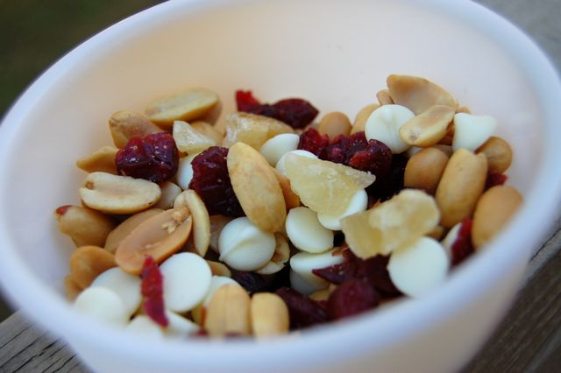

[This Photo](http://www.adventuroo.com/2009/11/the-perfect-trail-mix-for-my-selective-nut-allergy/) by Unknown Author is licensed under [CC BY-NC-ND](https://creativecommons.org/licenses/by-nc-nd/3.0/)

1. What percentage of her recommended daily intake is this?

|  |
| --- |
| **Question 5** **3 marks** |

1. Doug’s 60 cm television has a power rating of 150 W, while Jeremy’s 96 cm television is rated at 320 W. They both use their televisions for 1 hour every day. How much less energy will Doug’s television use per year?
2. What is the difference in cost in dollars if the cost of energy is 24c/kWh?